

CSCE 4980-02

Senior Project I

Group 6 - Classroom Monitoring Using AI

Data Collection Plan

Presented To:  
Dr. Sherif Aly

Dr. Hesham Eraqi

Table of contents:

1. Setting/Environment of Data collection
2. Test Subjects
3. Classes of cheating to collect our data based on
4. Size of Dataset in reference to literature.
5. Data augmentation and superimposing
6. Data collection plan figure
7. References
8. *Setting/Environment of Data collection*

The data collection setting for our initial dataset will be in AUC classrooms. The reason behind this choice is that the classrooms can be adjusted to be an exam setting with up to 20 to 25 students per classroom which will be enough for getting a huge amount of data by simulating cheating-like incidents based on the classes of cheating that we decided on considering the literature and that will be mentioned in section 3 of this paper.

1. *Test Subjects*

Our test subjects for our initial data set were ourselves(Group 6 members). and after getting the approval for the IRB form,we will include more people, mainly our colleagues, which will consist of 20 to 25 students to fill up the classroom that we are filming in and thus enrich our dataset.

1. *Classes of cheating to collect our data based on*

The classes of possible cheating according to the literature survey will consist of 6 classes: head movement, arm movement ,note passing, body direction, mobile phone detection and standing person. The head movement consists of moving the head in any direction that is not the exam paper. The arm movement which includes having the arms go out of the current student’s desk layout. Note passing is the passing of any object from one student to the other. Body direction involves having a student’s sitting position allow them to see another student’s paper without moving their head directly. Mobile phone detection is if any mobile phone is detected in frame for a student taking an exam. Last, standing person is anyone standing in the examination room to allow proctors to move freely in the examination room and not be detected as students.

1. *Size of Dataset in reference to literature.*

The size of data we planned as an initial set is 100 videos per class of cheating, each video is 1 min long. Each video is based on a script that contains the actions that we would like to treat as possible incidents of cheating for each class and also what are the actions that are considered not cheating, i.e normal behaviour for examinees, and thus we will apply our labeling based on that. Each video is captured with a camera with 60fps. This means that for each video we are collecting 3600 frames. So for each class with 100 videos, a total of 500 videos for the initial dataset, we are collecting 360,000 frames per class. The next phase of the data collection plan will be after acquiring the IRB approval, which we are expecting to get soon. We will increase the number of test subjects and search more for actions in each class so that we can increase our dataset.

In reference to the literature, the table below shows the dataset size which some of the important research papers in our literature review used and what we were trying to estimate the size of our dataset based on.

| Research Paper | Aim | Dataset Size |
| --- | --- | --- |
| Automatic Invigilation Using Computer Vision | A system based on computer vision is proposed in this paper. It will detect cheating by the detection of head and neck movements through a surveillance camera. | 30 thousand frames in total.The dataset had 5693 labelled images after pre-processing |
| Classroom student posture recognition based on an improved high-resolution network. . | a novel classroom student posture recognition method is proposed | This dataset includes 149,808 pictures and over 250,000 person instances labeled with 17 key point |
| A computer-vision based application for student behavior monitoring in classroom.[ | The objective  of this research was to build an automatic system that allowed the faculties to capture and make a  summary of student behaviors in the classroom as a part of data acquisition for the decision making  process. | recorded; 1800 frames were extracted from six videos. Each frame contained 10 to 20 students. |
| Student Behavior Recognition System for the Classroom Environment Based on Skeleton Pose Estimation and Person Detection | The objective  of this research was to build a recognition system for classroom environment to detect students activities | 11,500 images |

1. *Data augmentation and superimposing*

We will also apply data augmentation on our dataset, which can take different forms for whether it's about image inversion, changing brightness levels and more in order to increase the size of training data for models and help the model account for different situations that would be difficult to acquire training data sets for[5]. Another path is also generating our own synthetic data from existing ones, using tools that superimpose objects into images or videos, and thus can help achieve better data with more cases to consider.

1. *Data Collection Plan Figure*

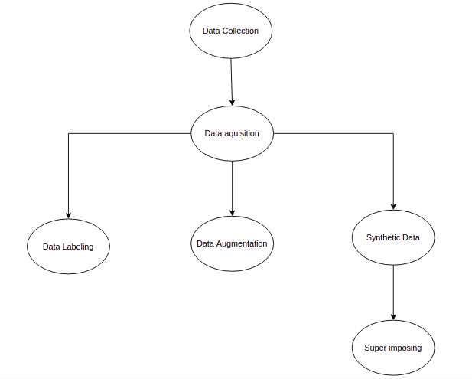

This figure summarizes the data collection plan. First the data acquisition where we record our videos, then we do the labeling or the classifying for each vidoes set based on the class and we classify then whether it is cheating or no and using python script we trim the videos, and at the eventually we have set of videos having specifically the cheating scenarios based on the class of cheating and another set of videos where no cheating action is occurring. The next step is augmenting the data so that we can increase the data and make use of the different factors of data augmentation. Lastly the generation of synthetic data by the means of superimposing objects in our data so that we can create scenarios that may be infeasible to achieve.

1. *References*
2. Lin F-C, Ngo H-H, Dow C-R, Lam K-H, Le HL. Student Behavior Recognition System for the Classroom Environment Based on Skeleton Pose Estimation and Person Detection. Sensors. 2021; 21(16):5314. <https://doi.org/10.3390/s21165314>
3. Malhotra, Manit, and Indu Chhabra. Automatic Invigilation Using Computer Vision
4. Zhang, Y., Zhu, T., Ning, H. et al. Classroom student posture recognition based on an improved high-resolution network. J Wireless Com Network 2021, 140 (2021). <https://doi.org/10.1186/s13638-021-02015-0>
5. Ngoc Anh, B., Tung Son, N., Truong Lam, P., Phuong Chi, L., Huu Tuan, N., Cong Dat, N., Huu Trung, N., Umar Aftab, M., & Van Dinh, T. (2019). A computer-vision based application for student behavior monitoring in classroom. *Applied Sciences*, *9*(22), 4729. https://doi.org/10.3390/app9224729
6. Shorten, C., Khoshgoftaar, T.M. A survey on Image Data Augmentation for Deep Learning. *J Big Data* 6, 60 (2019). <https://doi.org/10.1186/s40537-019-0197-0>